**MES Abasaheb Garware College**

**Karve Road Pune 411004 (2024-**

**2025)**

**M.sc(Computer Science) Semester**

**II**

A Project Report On

**Café Management System**

Submitted By

Ritesh More -15465

Harsh Harke – 15443

Gaurav Pardeshi- 15456

# Project Guide

Mrs. Chitra Nagarkar

## Acknowledgement

This project was an ambitious work and would have never been completed without the facilities provided by the ma’am and the sincere efforts of my faculty colleagues guided me helped this project.

My sincere “THANKS” goes to:

I want to express my gratitude and sincere thanks to our Faculty and HOD of dept. **Mrs. Chitra Nagarkar** for providing better working environment for competing this project successfully.

Lastly my thanks to my subject teachers and all my friends for inspiring my spirit to achieve this target.

Ritesh More

Roll no :- 15465

Harsh Harke

Roll no :- 15443

Gaurav Pardeshi

Roll No : 15456

Master of Computer Science.

**Introduction**

As the name suggests " Café Management System" is a platform for users to manage, sort and keep the stock of Food items updated in the cafe we felt the need to develop this system. Because if things are not organized properly it quickly becomes finding a needle in a haystack and all things may collapse.

**Existing System**

Existing systems are more expensive than traditional case registers and are not specifically designed for cafes.

So they do provide some features and functionality but not all which are required for managing a cafe efficiently.

As they are more expensive they are not a economically viable option. So cafe owners use registers books and all manual ways to manage the accounts and activities which harm the business. Existing systems are bug prone.

**Scope of the system**

They are not designed specifically for cafes and if they are Analysis quite expensive so the large number of cafe owners don’t use them. Existing systems can be used to do managing tracking updating items in cafe .

Project perspective features:

1. Economically viable option
2. Easy to use
3. Bug free
4. Give valuable insights

**Feature of the system**

1. **Add order**: Manage orders for multiple tables simultaneously, improving efficiency during peak hours. A user-friendly interface lets staff quickly add items to orders.
2. **Manage order**: Update menus in real-time to reflect ingredient availability, daily specials, or price changes. This eliminates confusion for both staff and customers.
3. **Add Product**: The "Add Order" function is the heart of your cafe management system. It allows you to efficiently capture customer selections and streamline the ordering process.
4. **User Notification**: Receive instant notifications on low stock, completed orders, upcoming deliveries, and more. This allows for proactive inventory replenishment and timely order fulfillment.
5. **Social media notice**: The "Add Order" function is the heart of your cafe management system. It allows you to efficiently capture customer selections and streamline the ordering process.
6. **Dish Recommendations**: Our web app might recommend a chilled beverage made with mango pulp, milk, and ice cream. Sujata Mastani and The Cold Drink House are popular choices.
7. **Language Translation**: Integration with language translation tools to help travelers communicate more effectively in foreign countries where they may not speak the local language.
8. **User Reviews and Ratings**: Access to user-generated reviews and ratings for destinations, accommodations, and activities to help users make informed decisions.

**System Requirement**

**SOFTWARE**

**Front End :-** CSS -3, Bootstrap, HTML-5, JavaScript

**Back End :-**  PHP

**Database :-** MySQL

**Code Editor :-** VS Code

**Operating System `:-** Windows

**HARDWARE**

* + Processer: i3 and above
  + RAM: 1GB or Higher
  + Hard Disk: 128GB

## Feasibility Study

Feasibility study is conducted to determine if the project, upon completion, will serve the purpose of the organization considering the amount of work, effort, and time invested in it. It allows developers to foresee the future of the project and its usefulness. A feasibility study of a system proposal is conducted based on its workability, impact on the organization, ability to meet user needs, and effective use of resources. Therefore, when a new application is proposed, it typically undergoes a feasibility study before being approved for development.

The document provides the feasibility of the project being designed and lists various areas carefully considered during the feasibility study, such as Technical, Economic, and Operational feasibilities. The following are its features:

**Technical Feasibility:** The system must be evaluated from a technical perspective first. The assessment of this feasibility must be based on an outline design of the system requirements in terms of input, output, programs, and procedures. Having identified an outline system, the investigation must go on to suggest the type of equipment required and the method of developing and running the system once it has been designed. Technical issues raised during the investigation include:

* Does the existing technology suffice for the suggested one?
* Can the system expand if developed? The project should be developed in such a way that the necessary functions and performance are achieved within the constraints. The project is developed using the latest technology. Though the technology may become obsolete after some time, due to the fact that newer versions of the same software support older versions, the system may still be used. So, there are minimal constraints involved with this project. The system has been developed using Java, making the project technically feasible for development.

**Economic Feasibility:** The developing system must be justified by cost and benefit. Criteria ensure that effort is concentrated on projects that will give the best return at the earliest. One of the factors affecting the development of a new system is the cost it would require. Some of the important financial questions asked during the preliminary investigation include:

* The costs to conduct a full system investigation.
* The cost of hardware and software.
* The benefits in the form of reduced costs or fewer costly errors. Since the system is developed as part of project work, there is no manual cost to spend on the proposed system. Also, all the resources are already available, indicating that the system is economically feasible for development.

**Operational Feasibility:** Operational feasibility evaluates whether the proposed system will be able to operate smoothly within the organization's existing processes and procedures. It assesses factors such as user acceptance, ease of integration with existing systems, and the availability of necessary resources for system implementation and maintenance. Operational issues raised during the investigation include:

* Will users be able to adapt to the new system easily?
* Can the system be integrated seamlessly into existing workflows?
* Are the required resources, such as personnel and training, available for system implementation and maintenance? By addressing these operational concerns, the feasibility study ensures that the proposed system will be practical and beneficial for the organization's operations."

**Analysis and Design**

**1. An Entity-Relationship (ER) Diagram :-** diagram is a visual representation used in database design to illustrate the relationships between entities within a system. It depicts the entities (such as people, objects, or concepts), their attributes, and the connections or associations between them. This diagram provides a clear overview of the database structure, helping stakeholders understand how data is organized and related in the system.

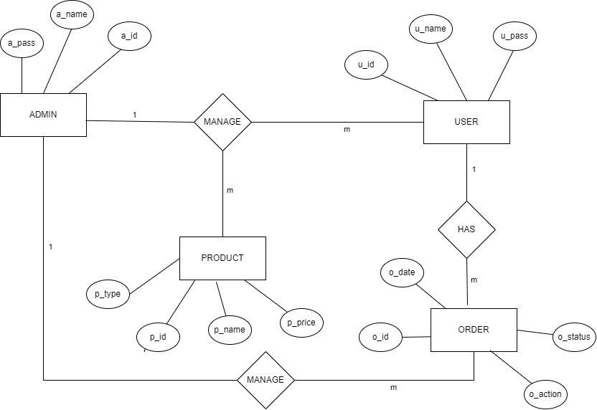

**2.Class diagram** is a visual representation in UML that showcases the structure of a system by illustrating classes, their attributes, methods, and relationships. It helps developers understand the architecture, design patterns, and dependencies of a software application.

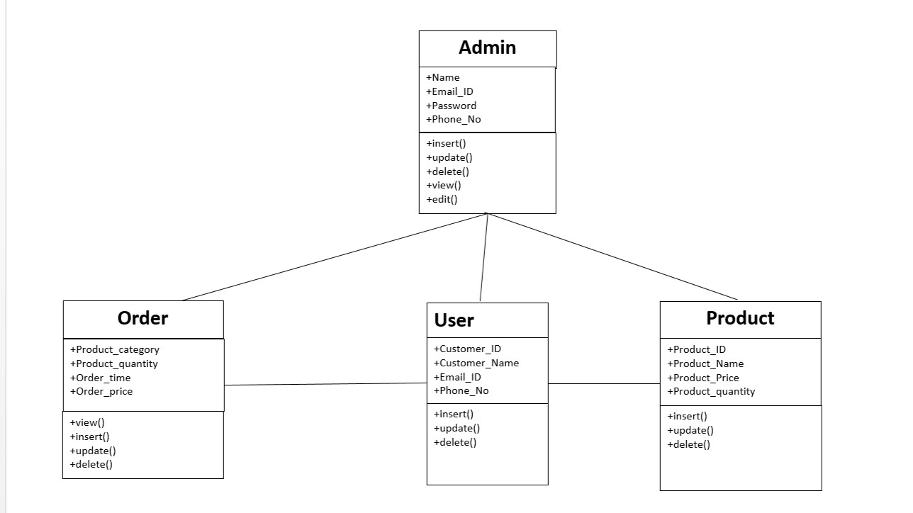

1. **Activity diagrams** help in visualizing the dynamic aspects of a system, showing how different activities interact and the order in which they occur. They are valuable for communication among stakeholders, design documentation, and understanding complex processes.

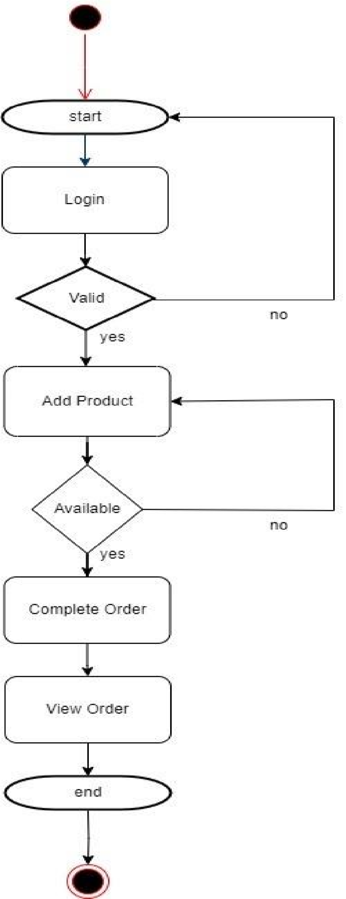

1. **Sequence Diagram** :- It illustrates the flow of messages or calls between objects or components over time, typically from the top of the diagram to the bottom. Sequence diagrams are particularly useful for visualizing the dynamic behavior of a system, including the order of method calls, the timing ofmessages, and the collaboration between different parts of the system.

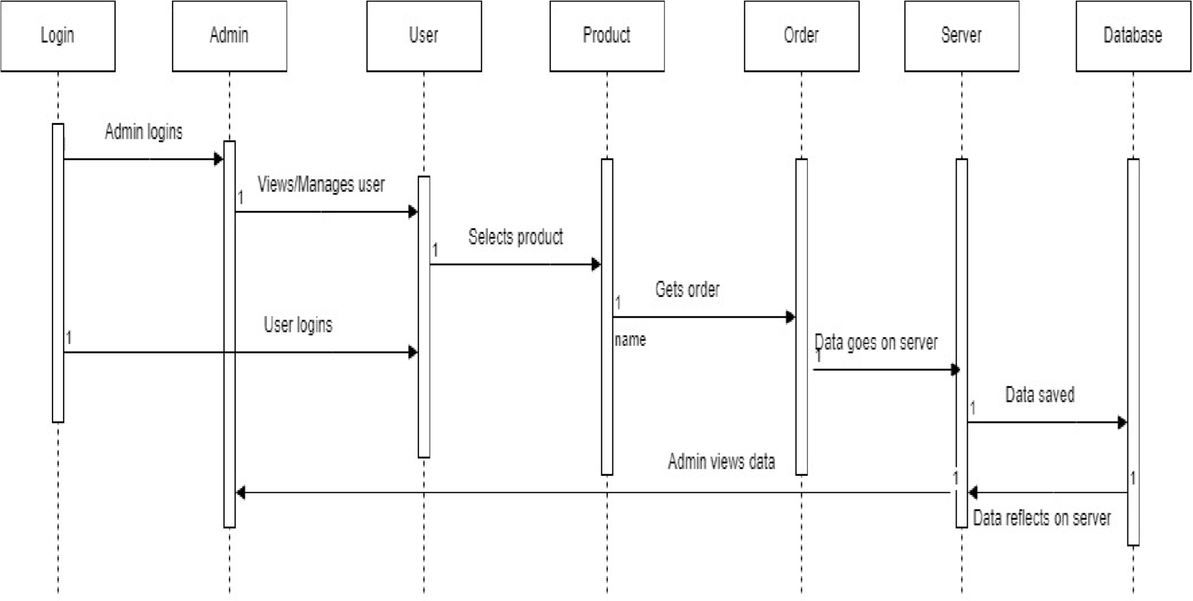

1. **Use Case Diagram :-** A use case diagram is a visual representation of the functional requirements of a system or software application. It depicts how users interact with the system and the various functionalities provided by the system to meet users' needs.

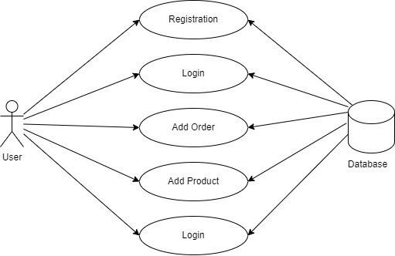

**Fig A.01. User – Use case**

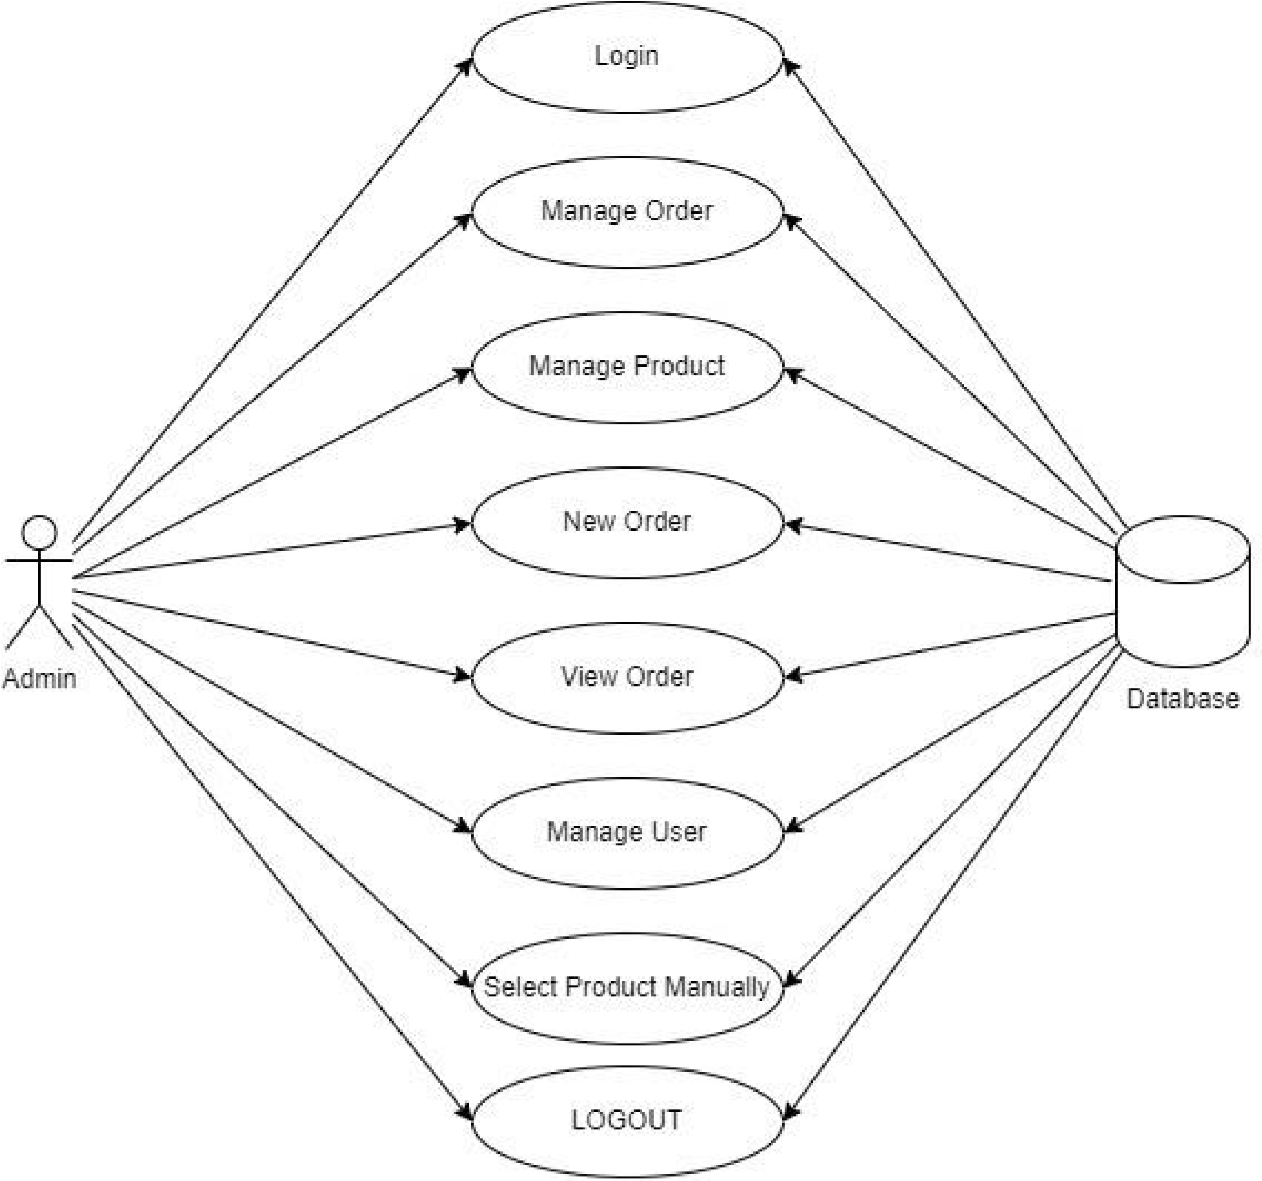

**Fig A.02. Admin– Use case**

1. **Deployment diagram**:-A deployment diagram is another type of UML (Unified Modeling Language) diagram that illustrates the physical deployment of software components within a system architecture. It shows how software components are distributed across hardware nodes (such as servers or devices) in a networked environment.

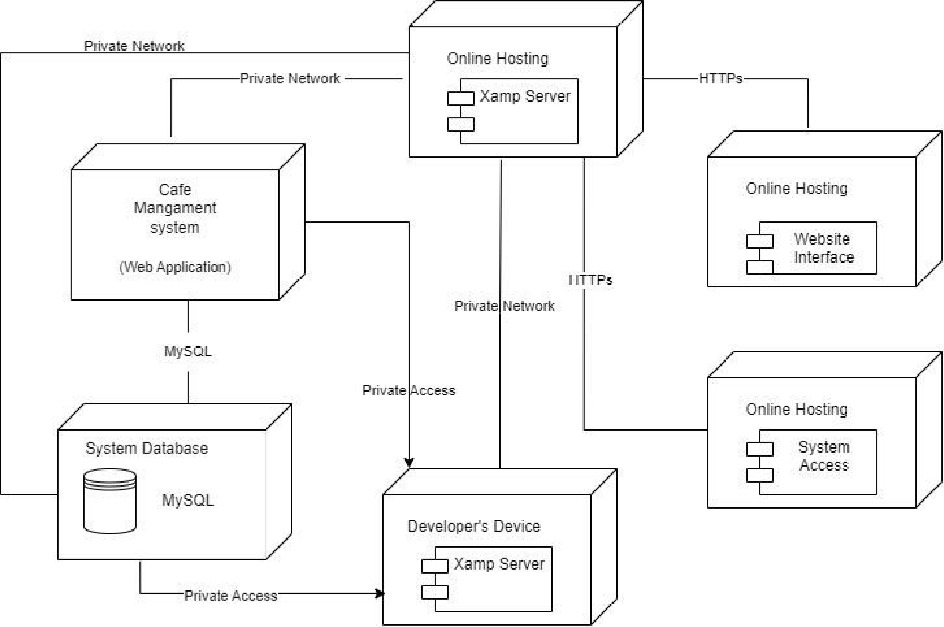

### Data Dictionary

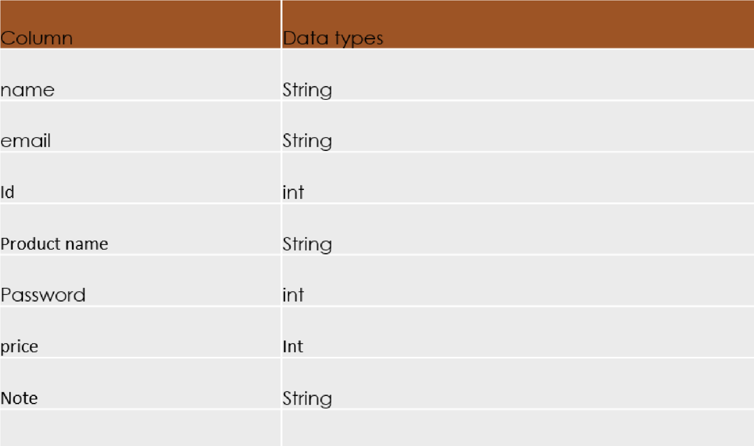

**Input Output Screen**

**Fig 01. Admin login**

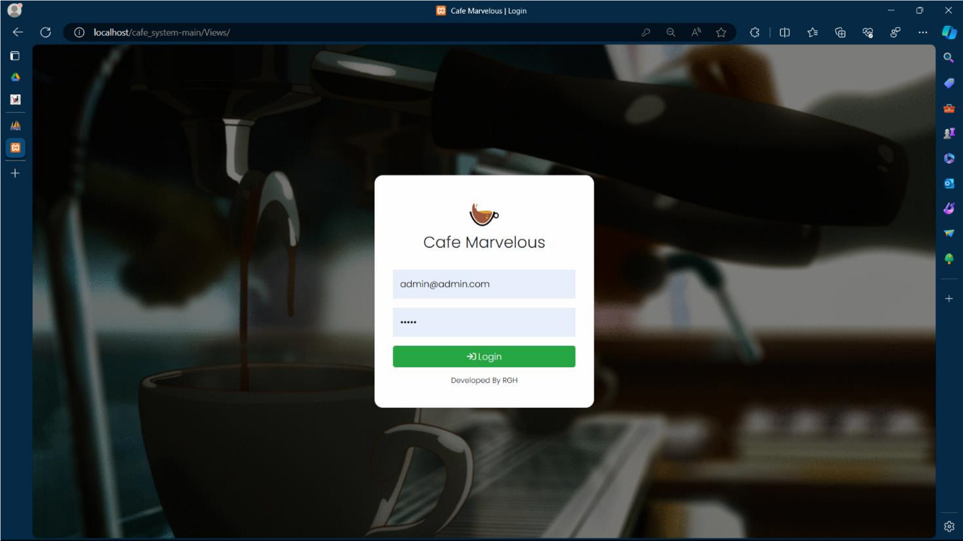

**Fig 02. Latest Order**

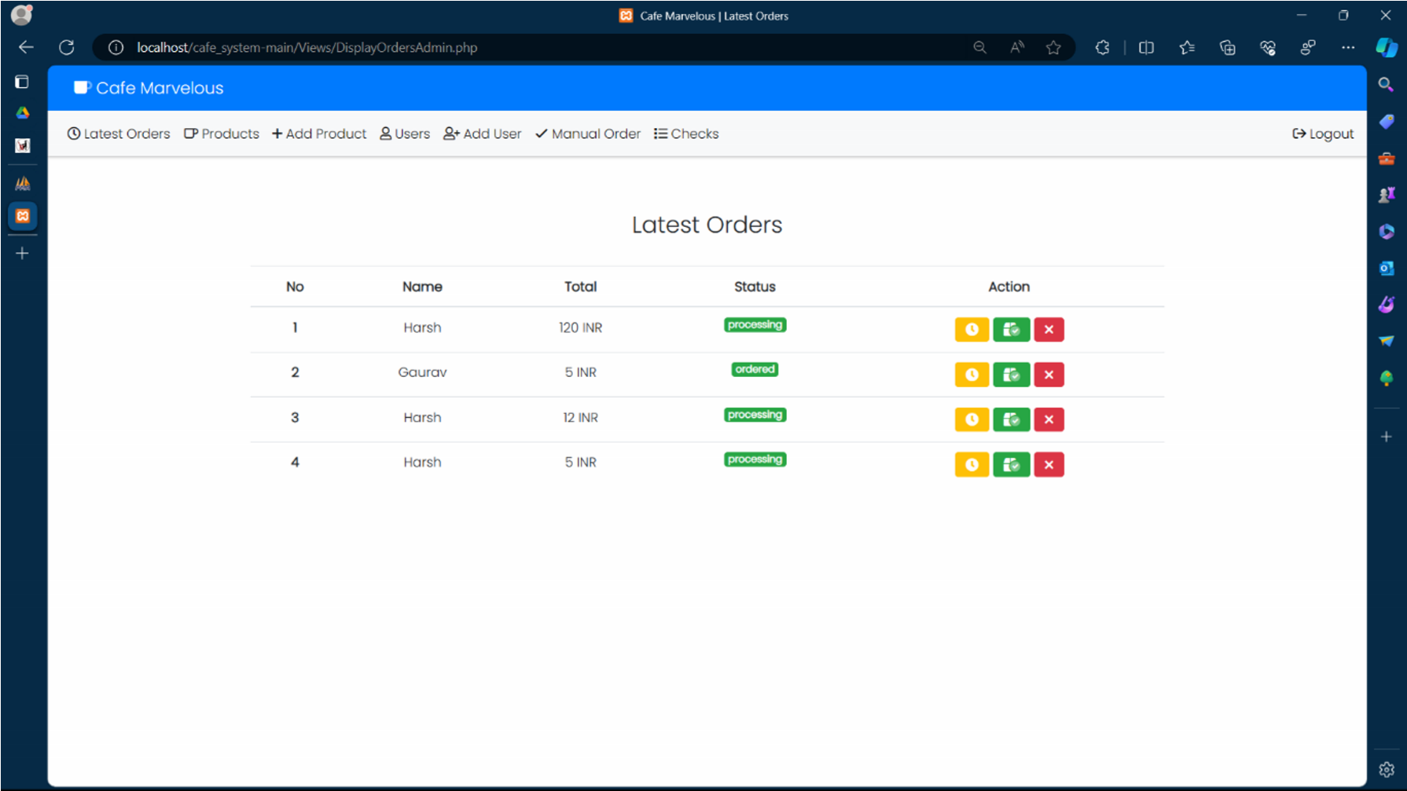

**Fig 03. Display orders**

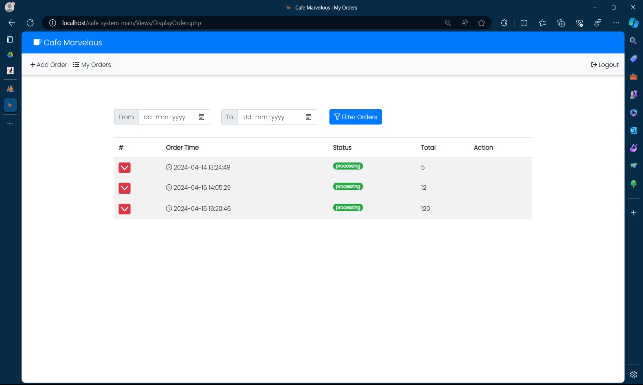

**Fig 04. Add new User**

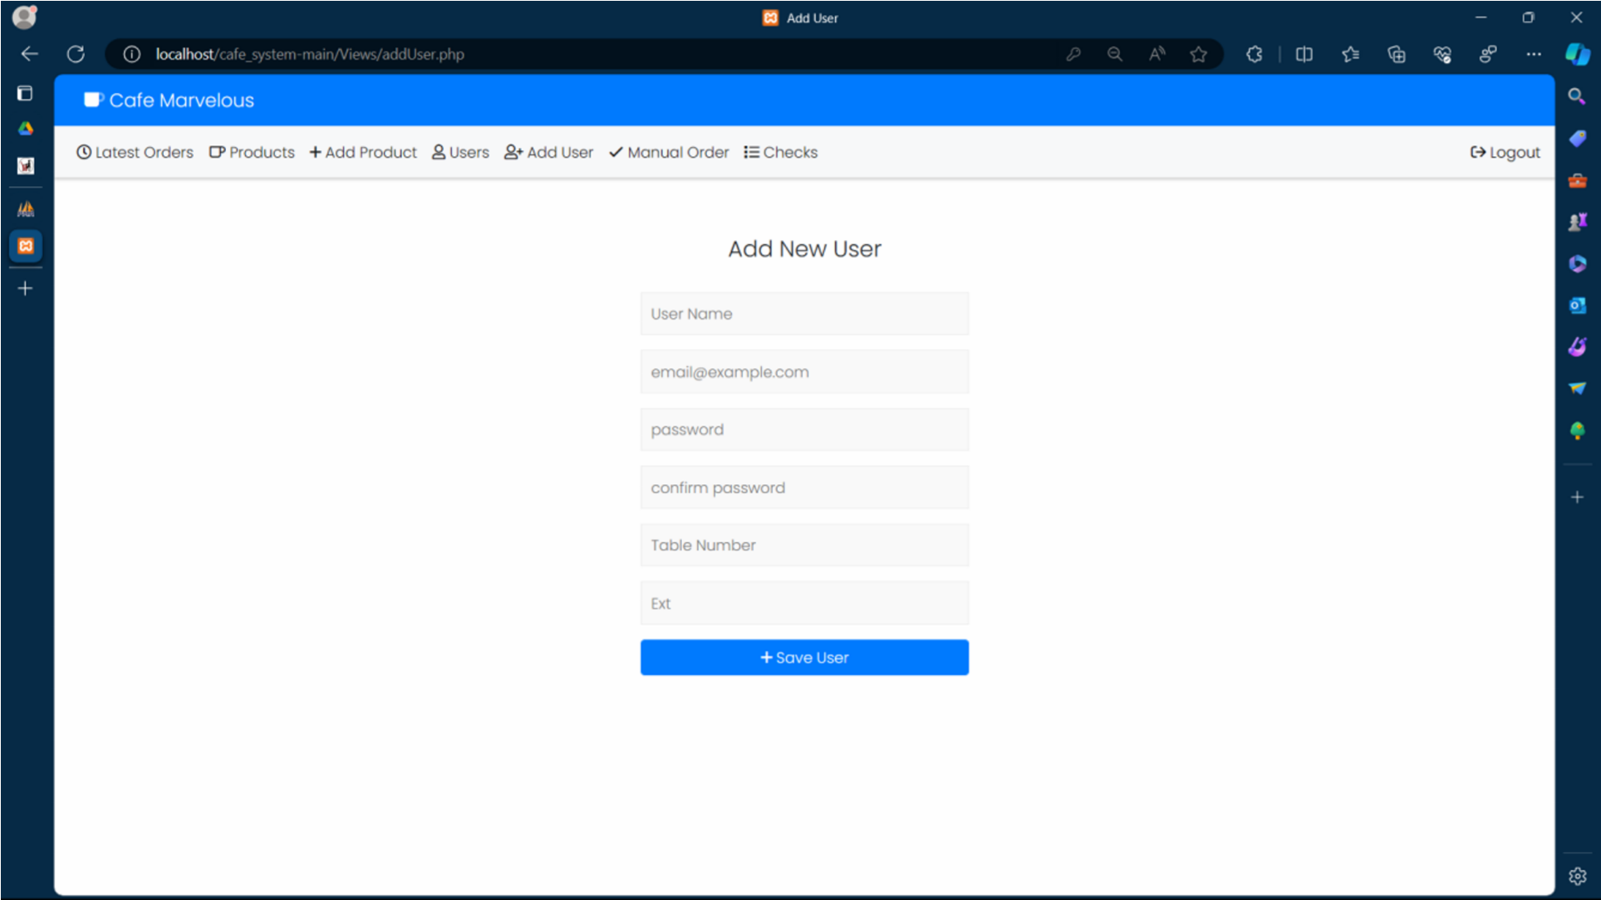

**Fig 05. User Login**

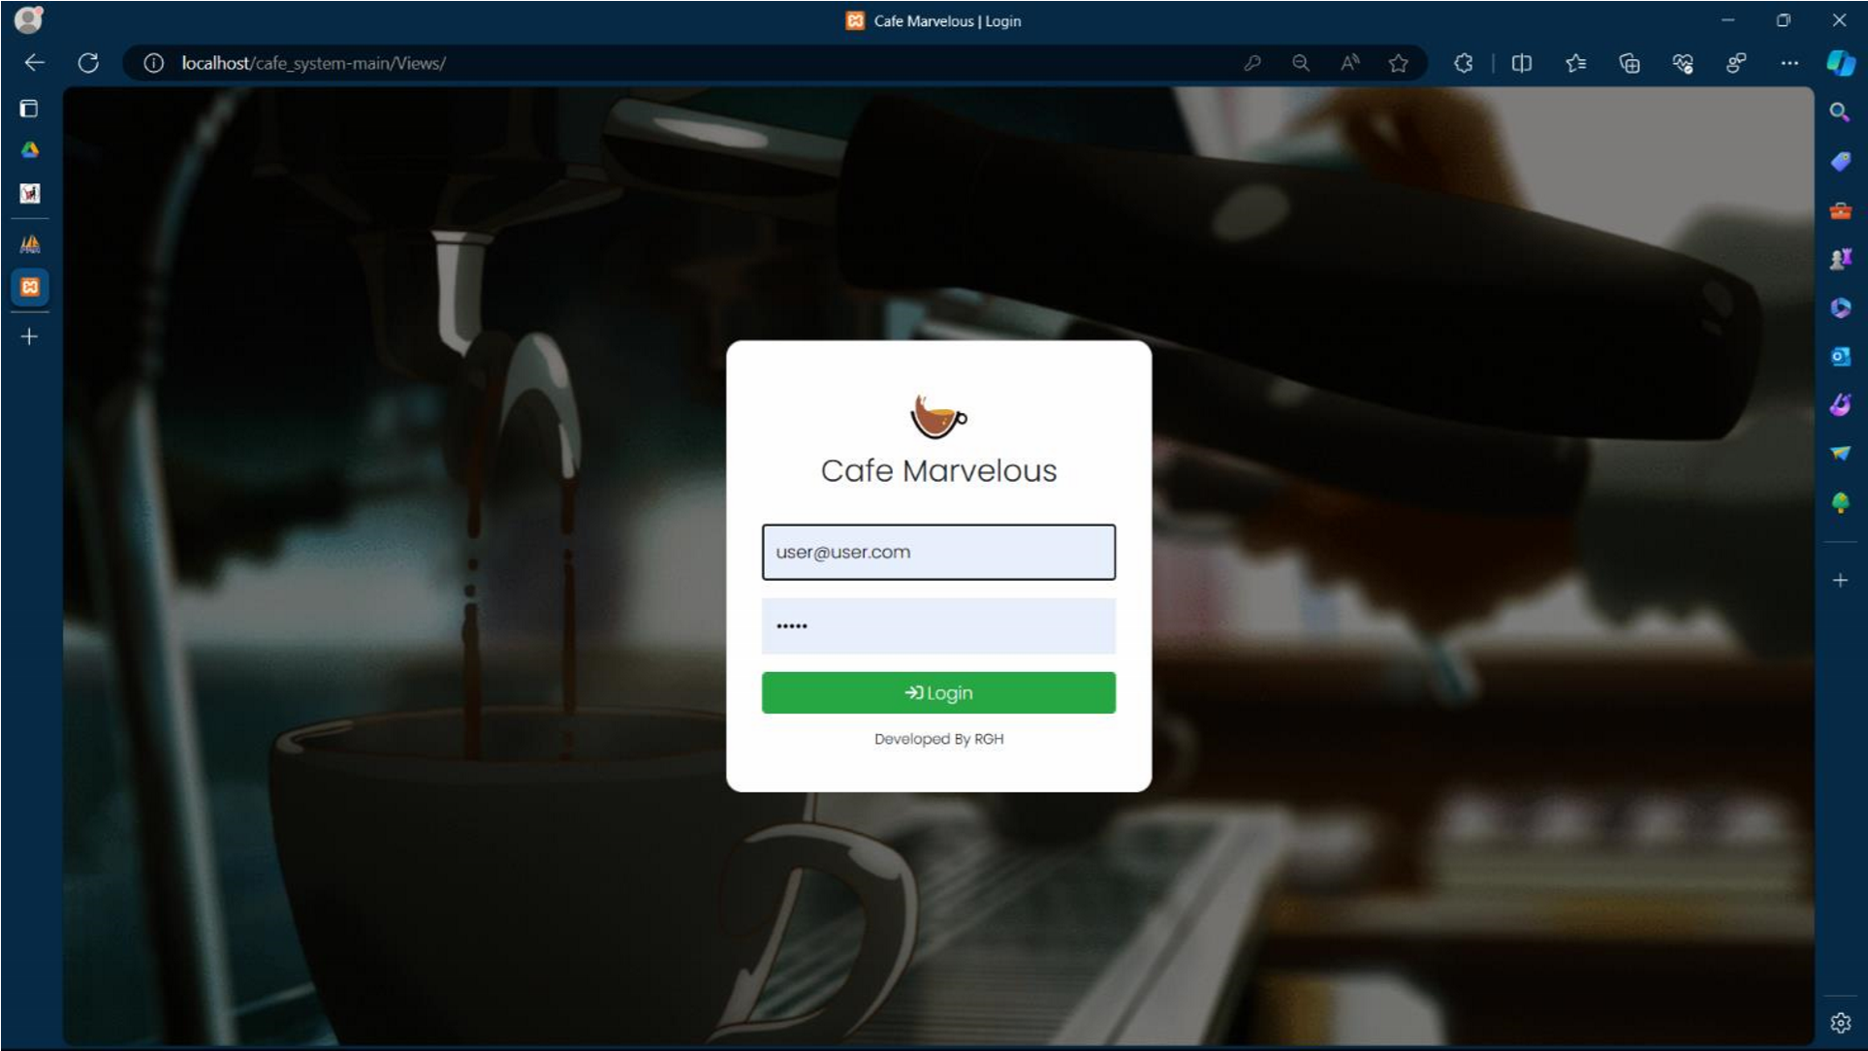

**Fig 06. Add Order**

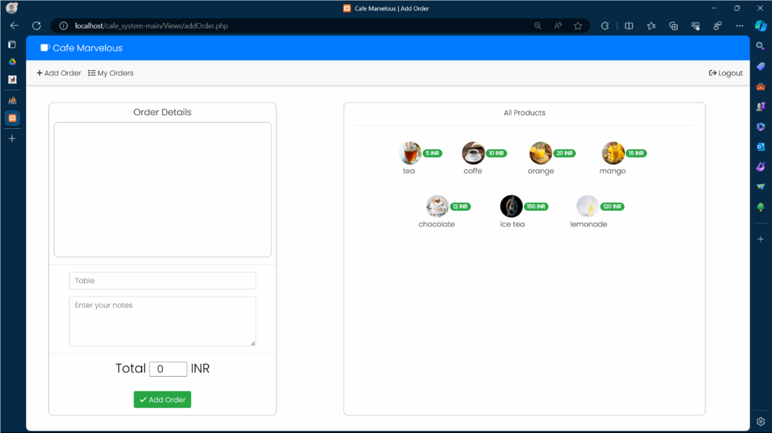

**Fig 07. Add Product**

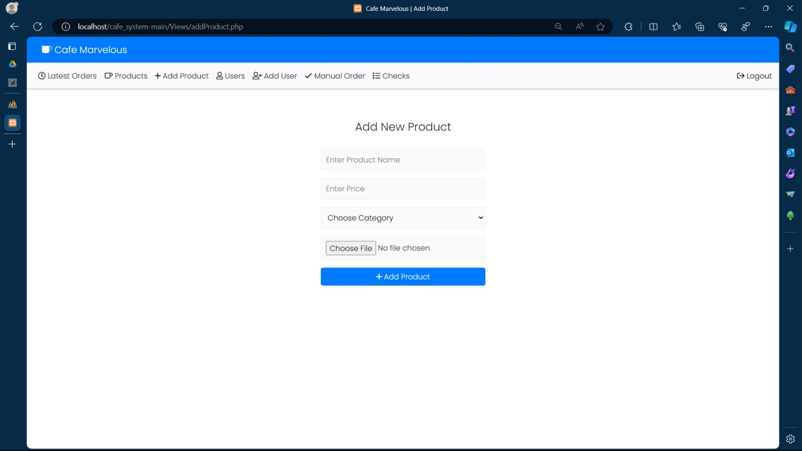

**Fig 08. Users**

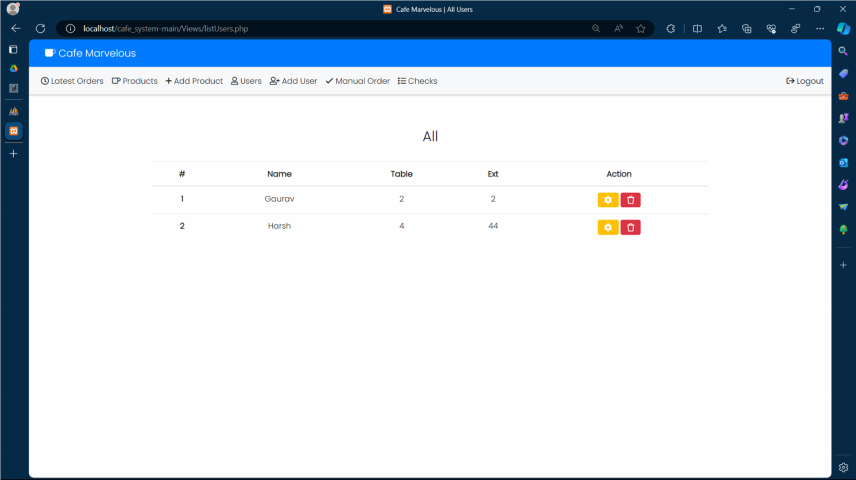

**Limitations/Drawbacks**

1. **Dependency on Technology:** The system heavily relies on technology, including internet connectivity and software applications. Any disruptions in technology infrastructure can affect the system's functionality and availability.
2. **Data Accuracy:** The accuracy of information provided by the system depends on the accuracy of the data sources it relies on. Inaccurate or outdated information could lead to misinformed decisions by users.
3. **Security Concerns:** Storing personal and financial information of users within the system poses security risks. Unauthorized access, data breaches, and cyber-attacks are potential threats that could compromise user data and privacy.
4. **User Adoption:** Users, particularly those unfamiliar with technology, may face challenges in navigating and utilizing the system effectively. User training and support may be required to ensure widespread adoption and usage.
5. **Limited Customization**: While the system may offer customizable features, there may be limitations in tailoring the experience to individual preferences and requirements. Some users may prefer personalized assistance and recommendations that the system cannot provide.
6. **Reliability of Third-party Services:** The system may rely on third-party services such as transportation providers, accommodation booking platforms, and weather APIs. Reliability issues with these services, such as downtime or inaccuracies, can impact the user experience.
7. **Geographical Limitations:** The system's coverage may be limited to specific regions or countries, limiting its usefulness for users traveling to areas outside of its scope.
8. **Over-reliance on Automation:** While automation streamlines processes, it may lead to a lack of human interaction and personalized assistance, which some users may prefer, particularly in complex travel situations or emergencies.

**Future Enhancement**

1. **Local Language Support:** Expand language options to include translations for key features and destination information, making the system more accessible to users worldwide.
2. **Budget Tracking:** Incorporate a budget tracking tool to help users monitor their Edible product expenses and stay within their planned budget.
3. **Offline Guides:** Develop downloadable offline guides for popular destinations, providing users with access to essential travel information even without internet connectivity.
4. **New Product Updates:** Provide new product updates for their convenience to help know and pack accordingly.
5. **Travel Journal:** Introduce a digital travel journal feature where users can document their experiences, upload photos, and share memories with friends and family.
6. **Local Events Calendar:** Include a calendar of local events and festivals happening at users' food choice, allowing them to discover and participate in cultural dish festivals during their travels.

**Bibliography**

* [www.theserverside.com](http://www.theserverside.com/)
* [www.javatpoint.com](http://www.javatpoint.com/)
* [www.W3cschool.com](http://www.w3cschool.com/)
* www.jsbyhrishikeshrajput.com